**ScienceQtech Employee Performance Mapping**

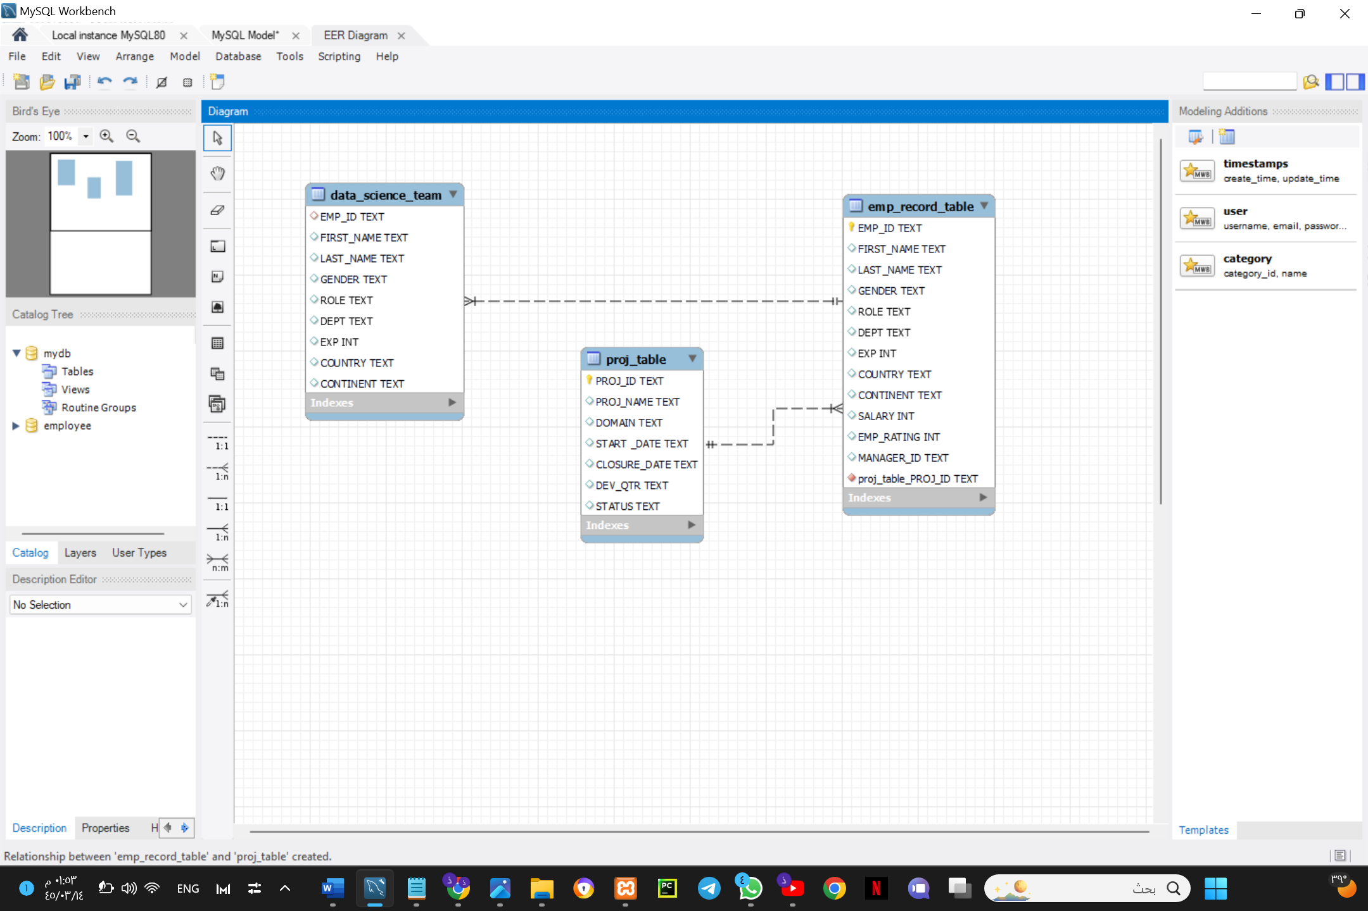**ER diagram:**

1. **Write a query to fetch EMP_ID, FIRST_NAME, LAST_NAME, GENDER, and DEPARTMENT from the employee record table, and make a list of employees and details of their department.**

SELECT EMP_ID, FIRST_NAME, LAST_NAME, GENDER, DEPT

FROM emp_record_table;

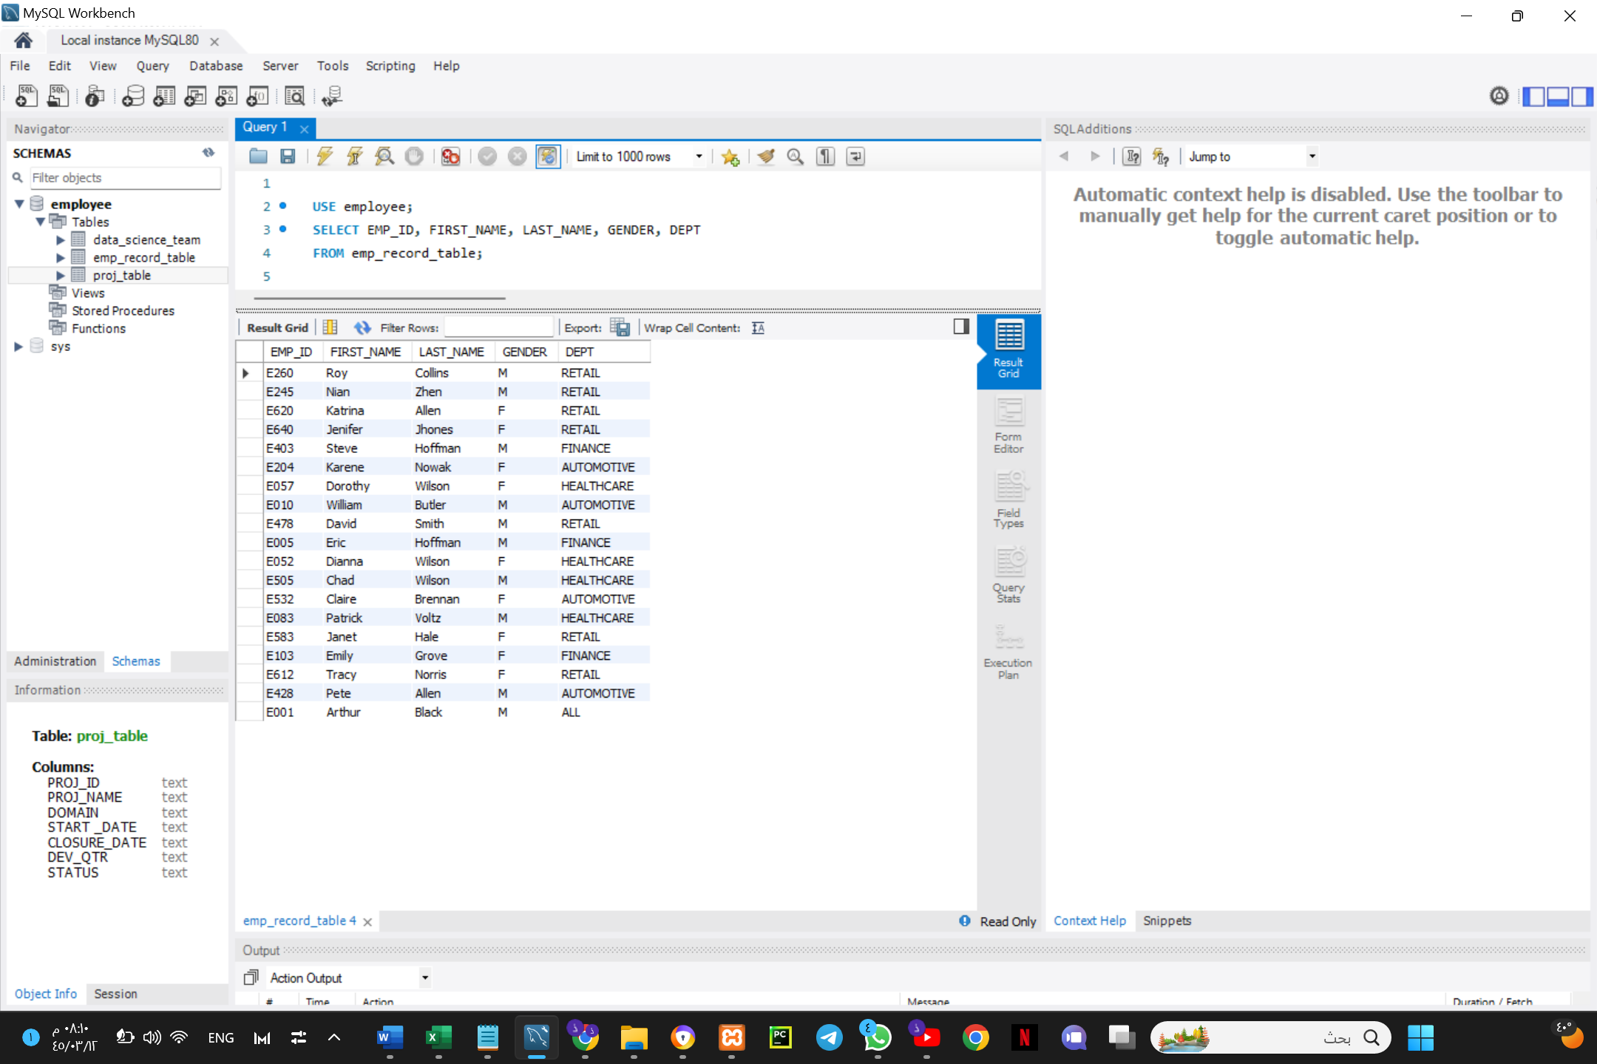

1. **Write a query to fetch EMP_ID, FIRST_NAME, LAST_NAME, GENDER, DEPARTMENT, and EMP_RATING if the EMP_RATING is:**

* **less than** **two**

SELECT EMP_ID, FIRST_NAME, LAST_NAME, GENDER, DEPT,EMP_RATING

FROM emp_record_table

WHERE EMP_RATING<2;

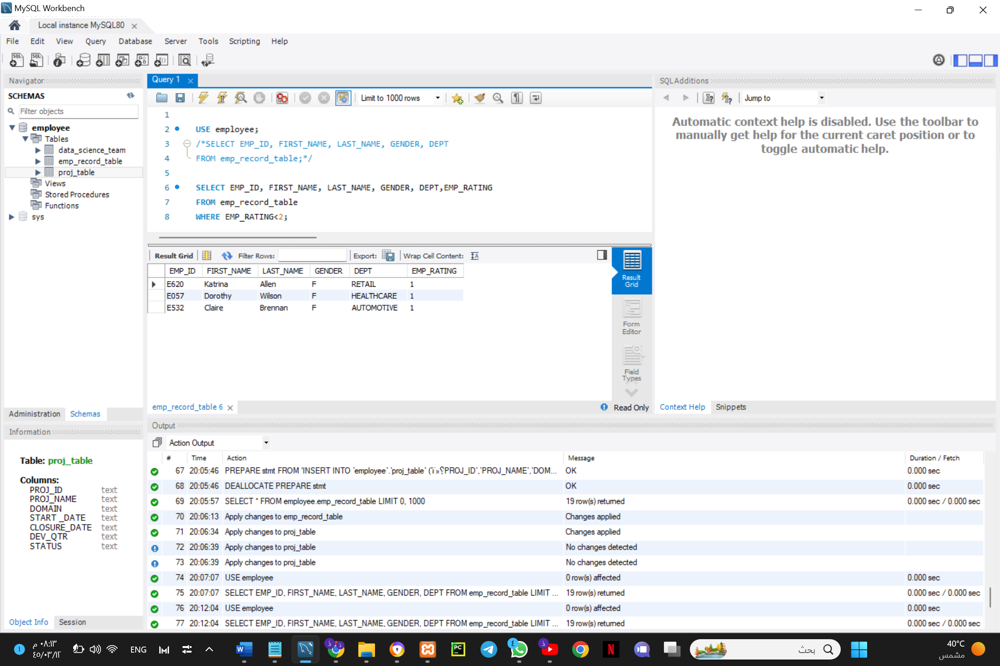

* **greater than four**

SELECT EMP_ID, FIRST_NAME, LAST_NAME, GENDER, DEPT,EMP_RATING

FROM emp_record_table

WHERE EMP_RATING>4;

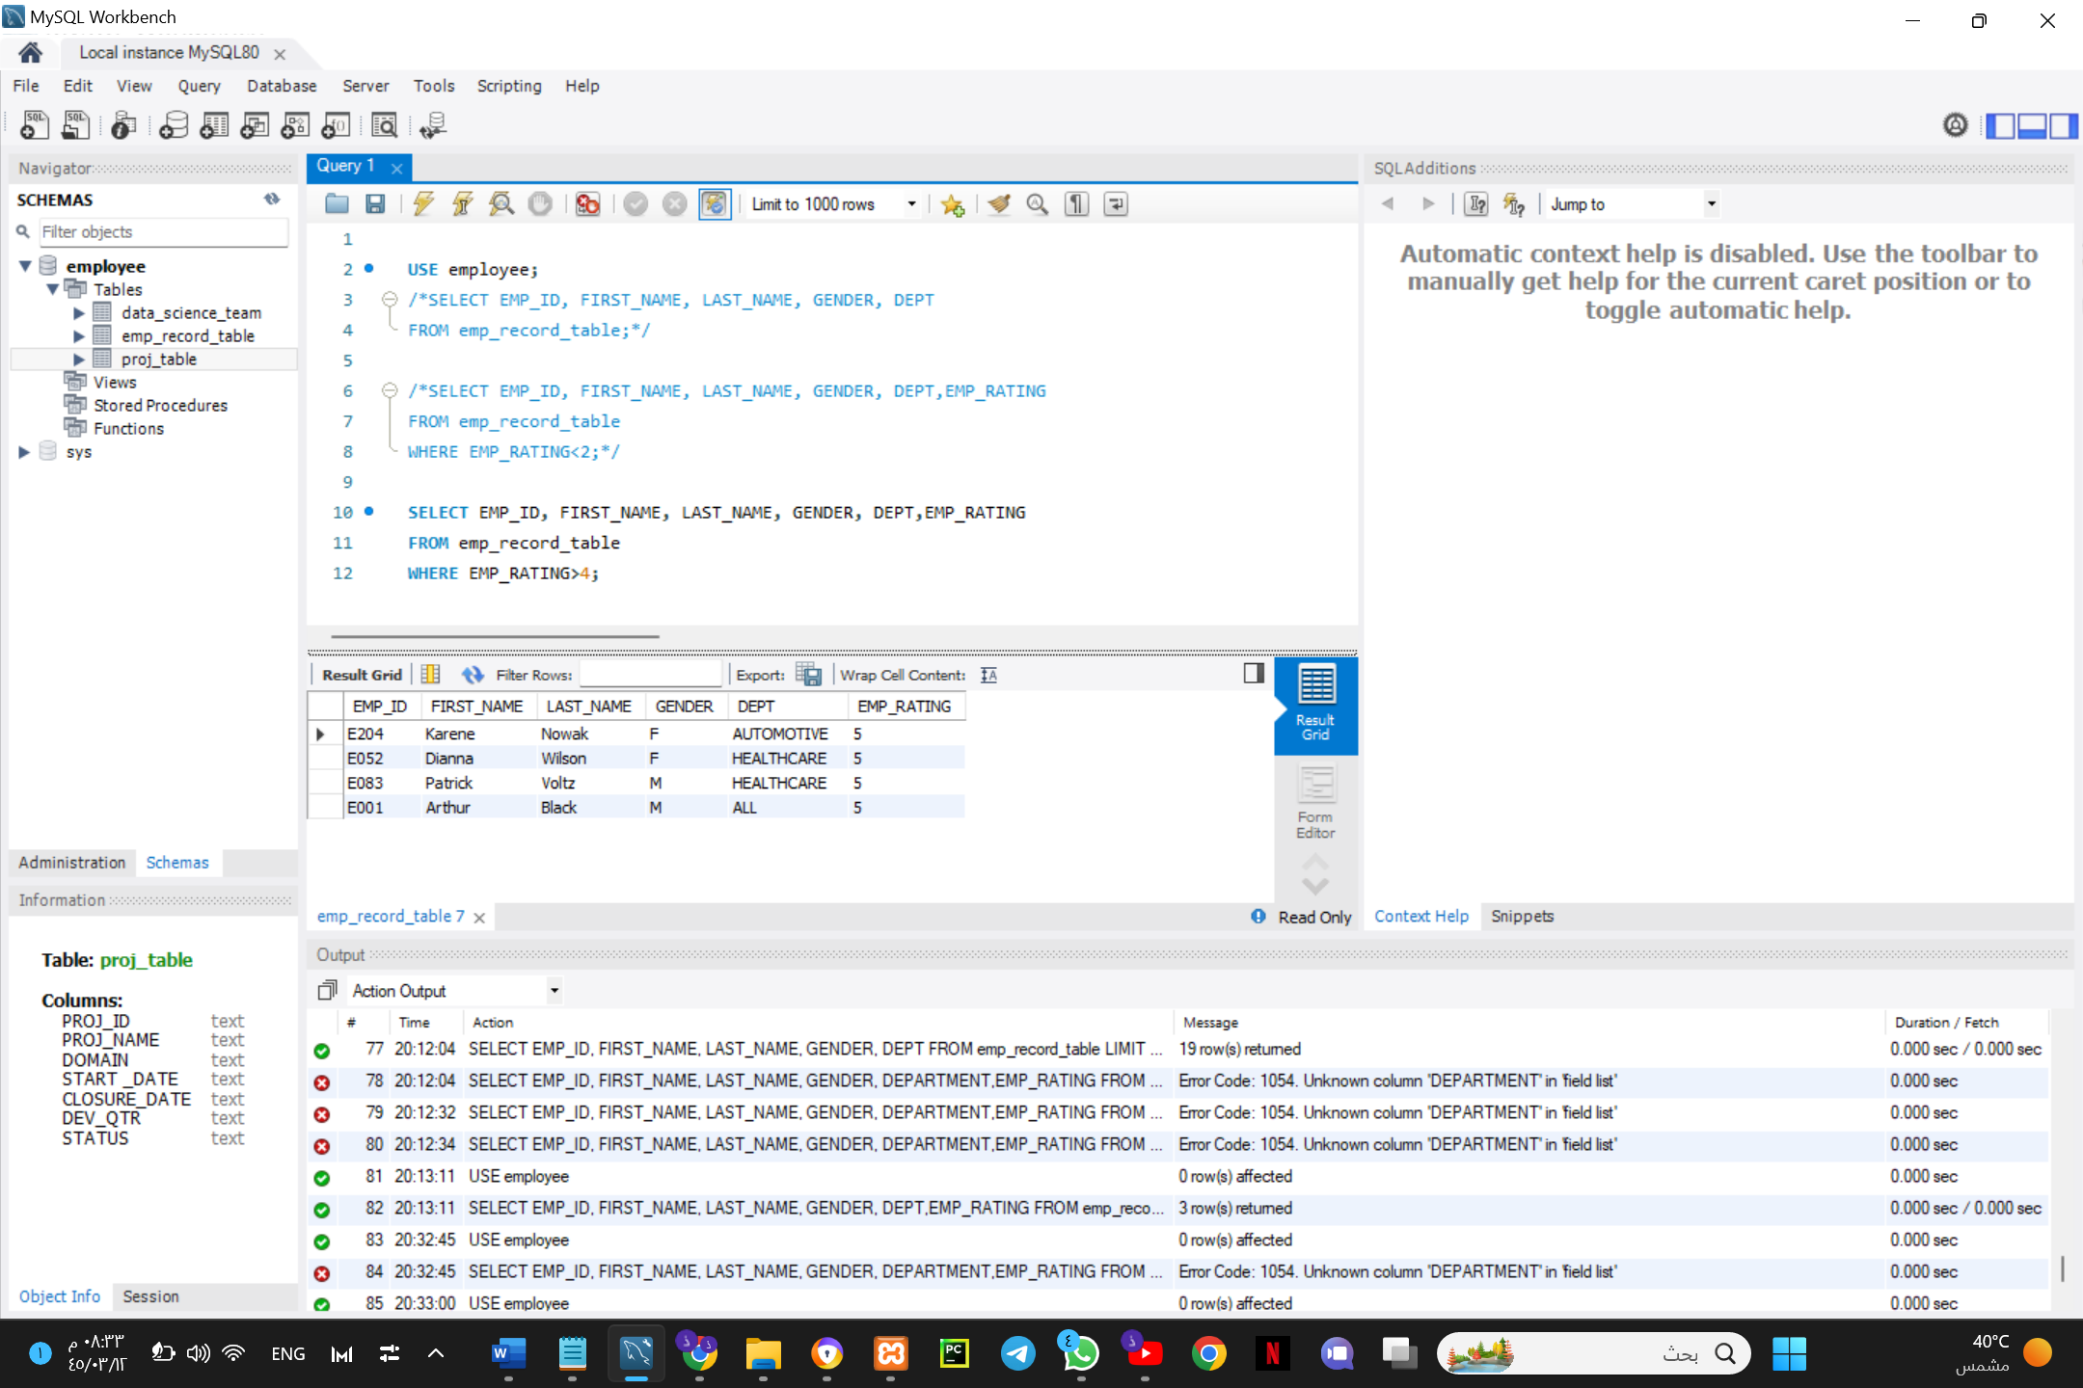

* **between two and four**

SELECT EMP_ID, FIRST_NAME, LAST_NAME, GENDER, DEPT,EMP_RATING

FROM emp_record_table

WHERE EMP_RATING BETWEEN 2 AND 4;

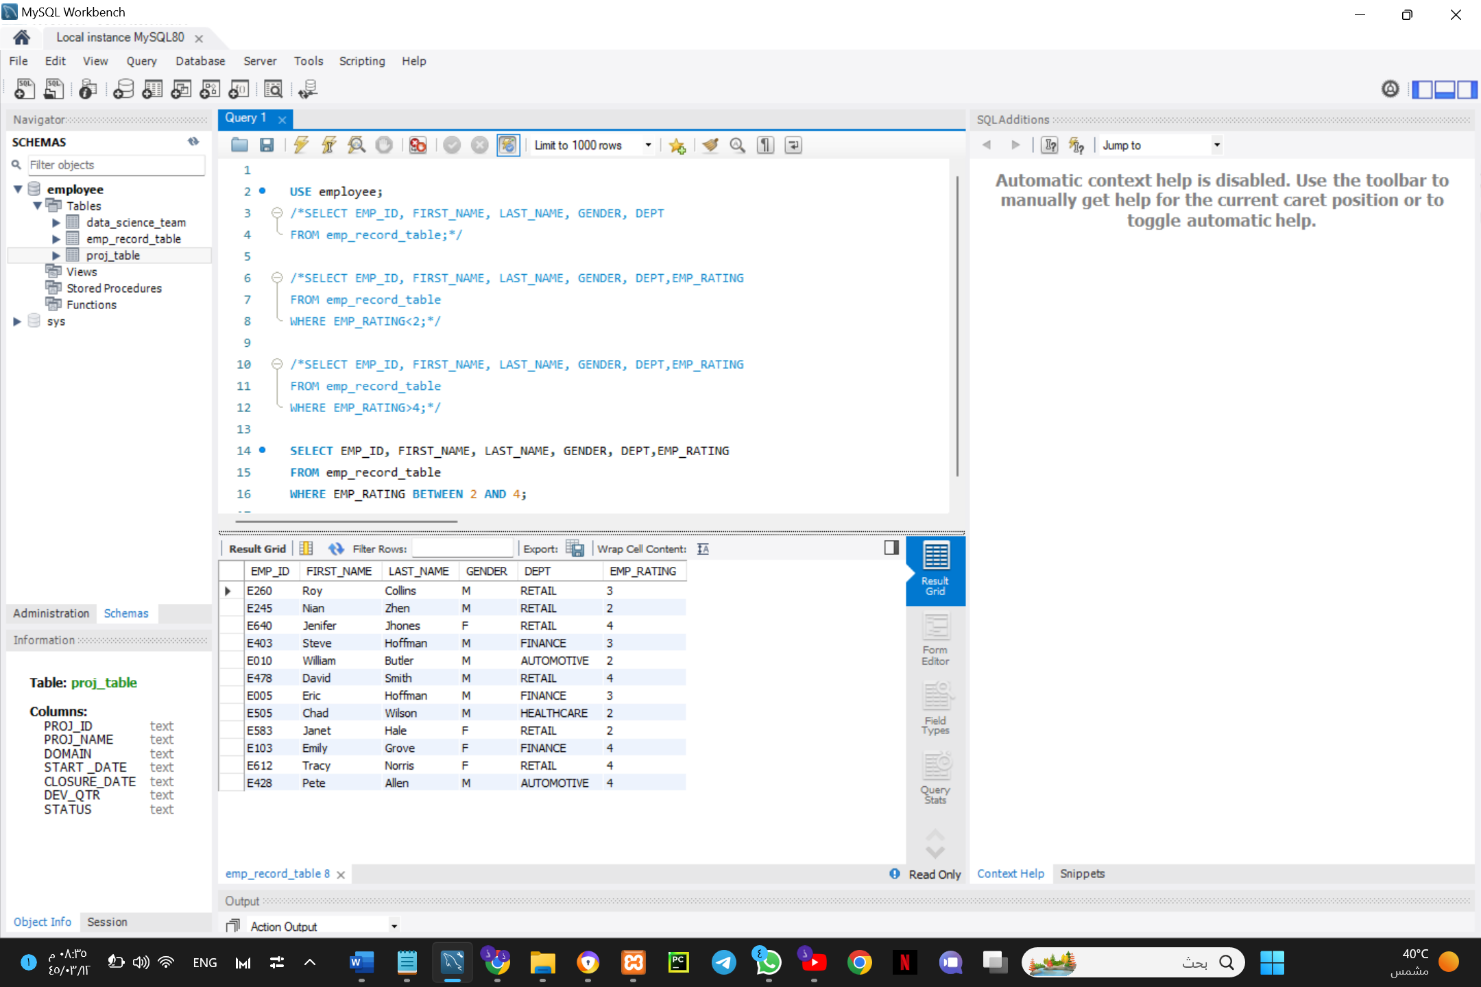

1. **Write a query to concatenate the FIRST_NAME and the LAST_NAME of employees in the Finance department from the employee table and then give the resultant column alias as NAME.**

SELECT CONCAT(FIRST_NAME, ' ', LAST_NAME) AS "NAME", DEPT

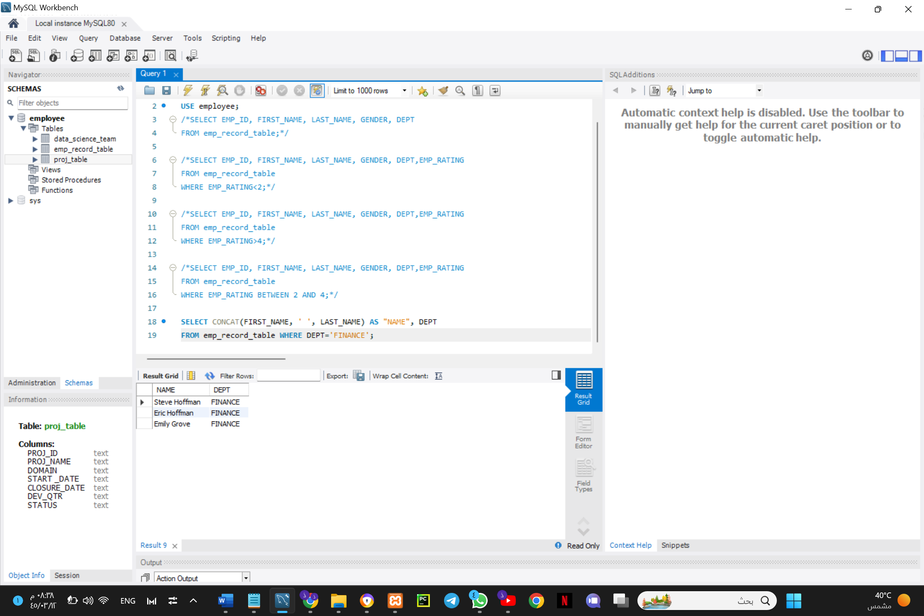FROM emp_record_table WHERE DEPT='FINANCE';

1. **Write a query to list only those employees who have someone reporting to them. Also, show the number of reporters (including the President).**

SELECT w.EMP_ID, w.FIRST_NAME, count(m.EMP_ID) AS 'Reporters'

FROM employee.emp_record_table AS w INNER JOIN employee.emp_record_table AS m

ON w.EMP_ID= m.MANAGER_ID

WHERE w.ROLE IN ('MANAGER', 'PRESIDENT')

GROUP BY w.EMP_ID, w.FIRST_NAME, w.LAST_NAME, w.ROLE, w.EXP, w.DEPT

ORDER BY w.EMP_ID;*

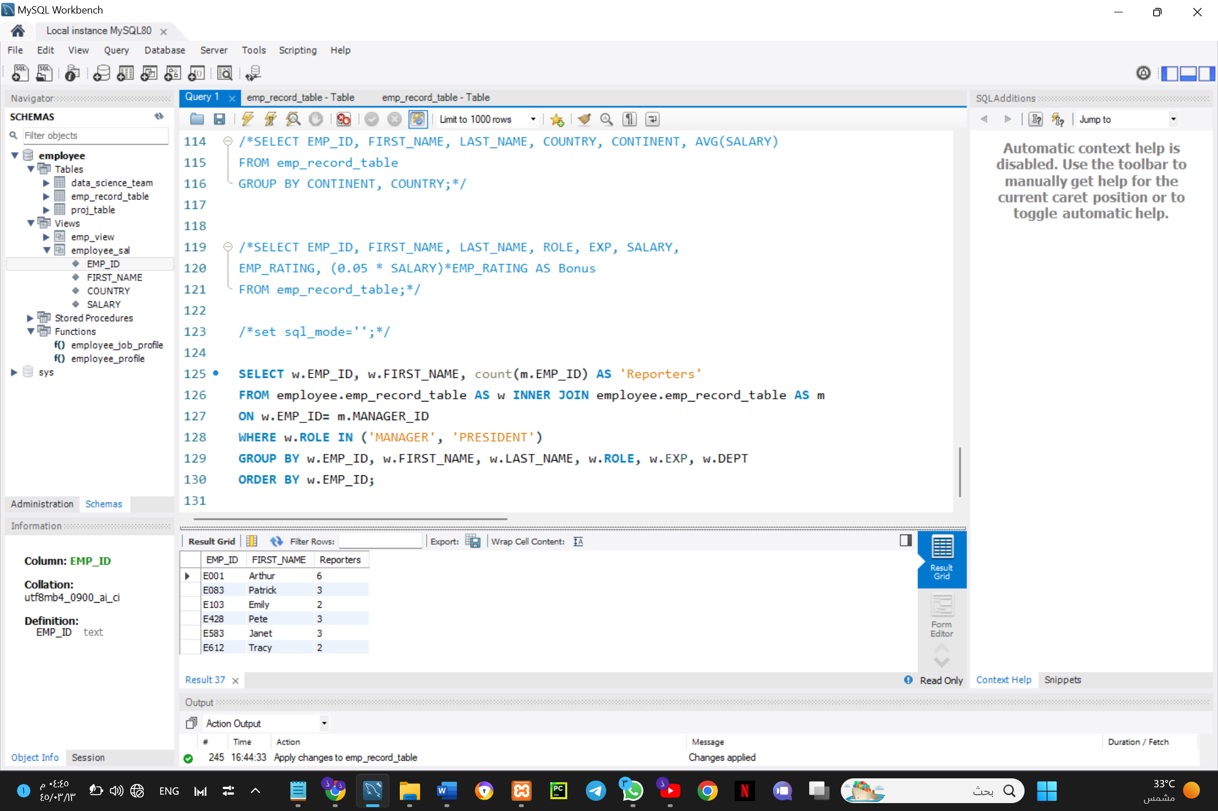

1. **Write a query to list down all the employees from the healthcare and finance departments using union. Take data from the employee record table.**

SELECT EMP_ID, FIRST_NAME, LAST_NAME, DEPT AS Department

FROM emp_record_table WHERE DEPT='HEALTHCARE'

UNION

SELECT EMP_ID, FIRST_NAME, LAST_NAME, DEPT AS Department

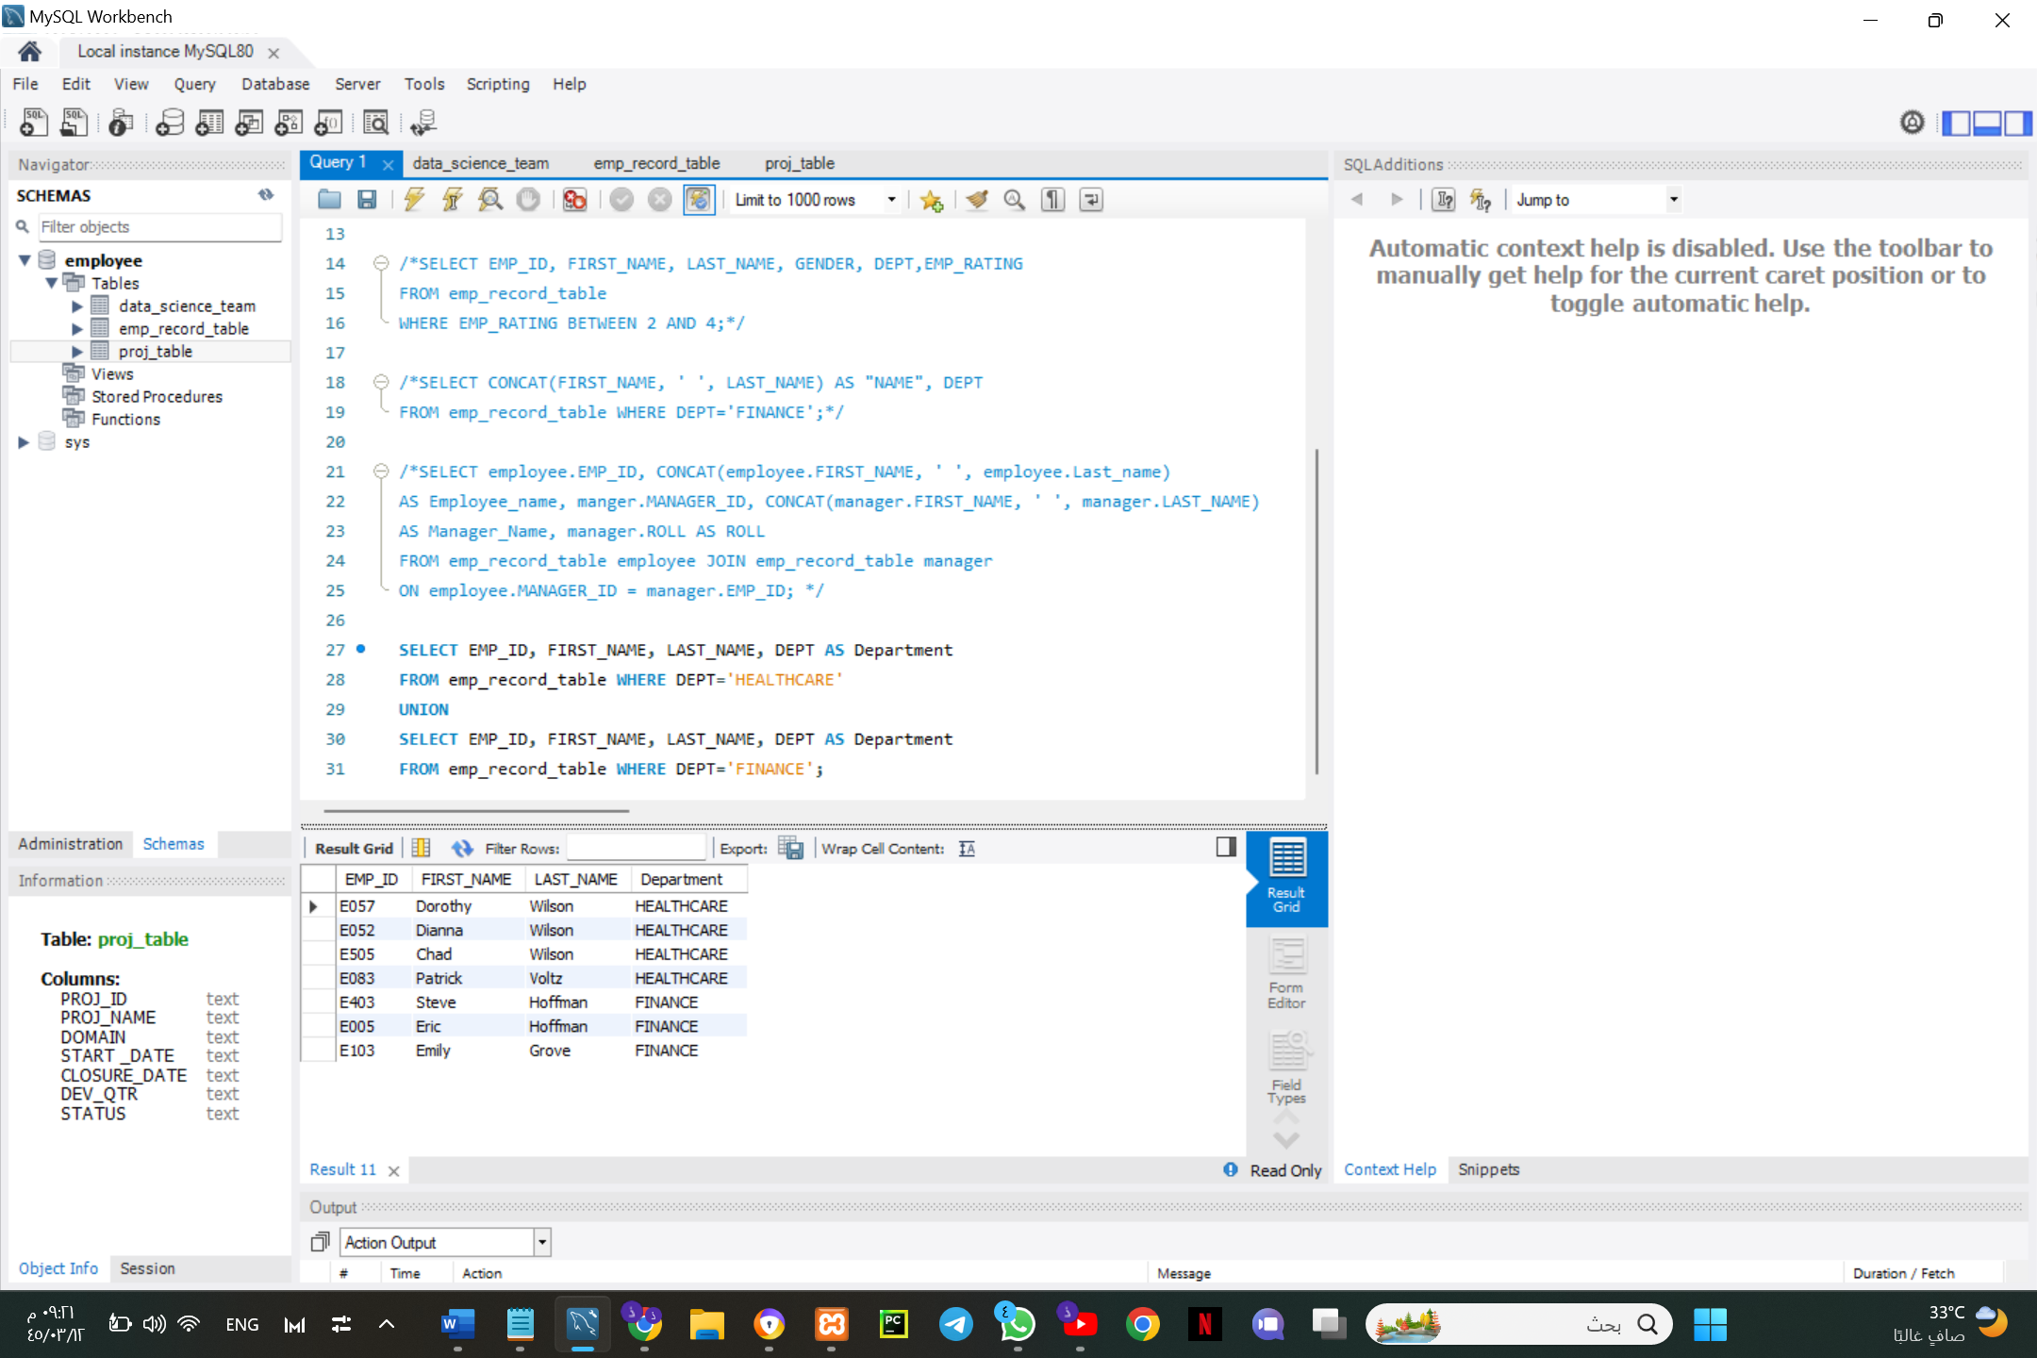FROM emp_record_table WHERE DEPT='FINANCE';

1. **Write a query to list down employee details such as EMP_ID, FIRST_NAME, LAST_NAME, ROLE, DEPARTMENT, and EMP_RATING grouped by dept. Also include the respective employee rating along with the max emp rating for the department.**

SELECT EMP_ID, FIRST_NAME, LAST_NAME, ROLE, DEPT, MAX(EMP_RATING)

FROM emp_record_table

GROUP BY DEPT;

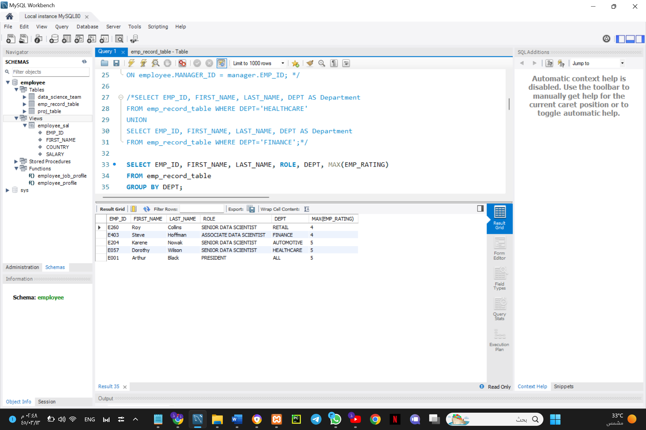

1. **Write a query to calculate the minimum and the maximum salary of the employees in each role. Take data from the employee record table.**

SELECT ROLE, MIN(SALARY) AS 'Minimum Salary', MAX(SALARY) AS 'Maximum Salary'

FROM emp_record_table

GROUP BY ROLE;

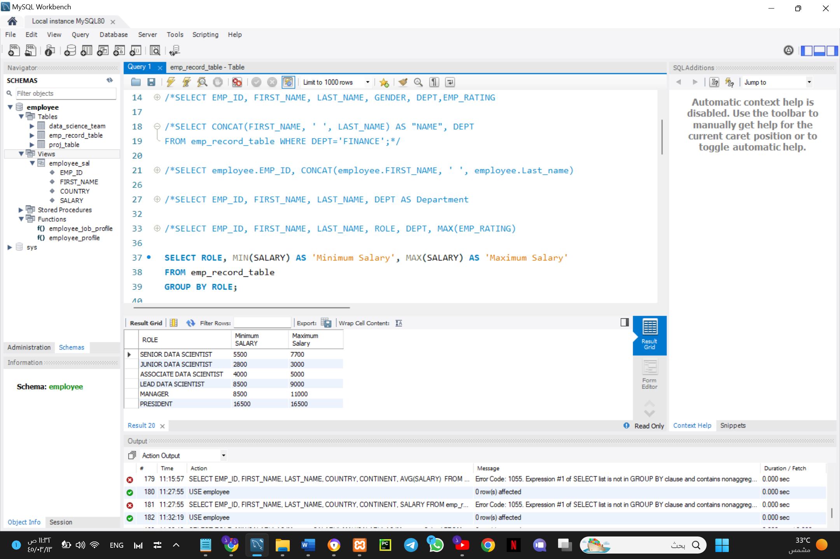

1. **Write a query to assign ranks to each employee based on their experience. Take data from the employee record table.**

SELECT EMP_ID, FIRST_NAME, LAST_NAME, ROLE, DEPT, EXP,

Rank() OVER (ORDER BY EXP DESC) AS 'Employees Ranking'

FROM emp_record_table;

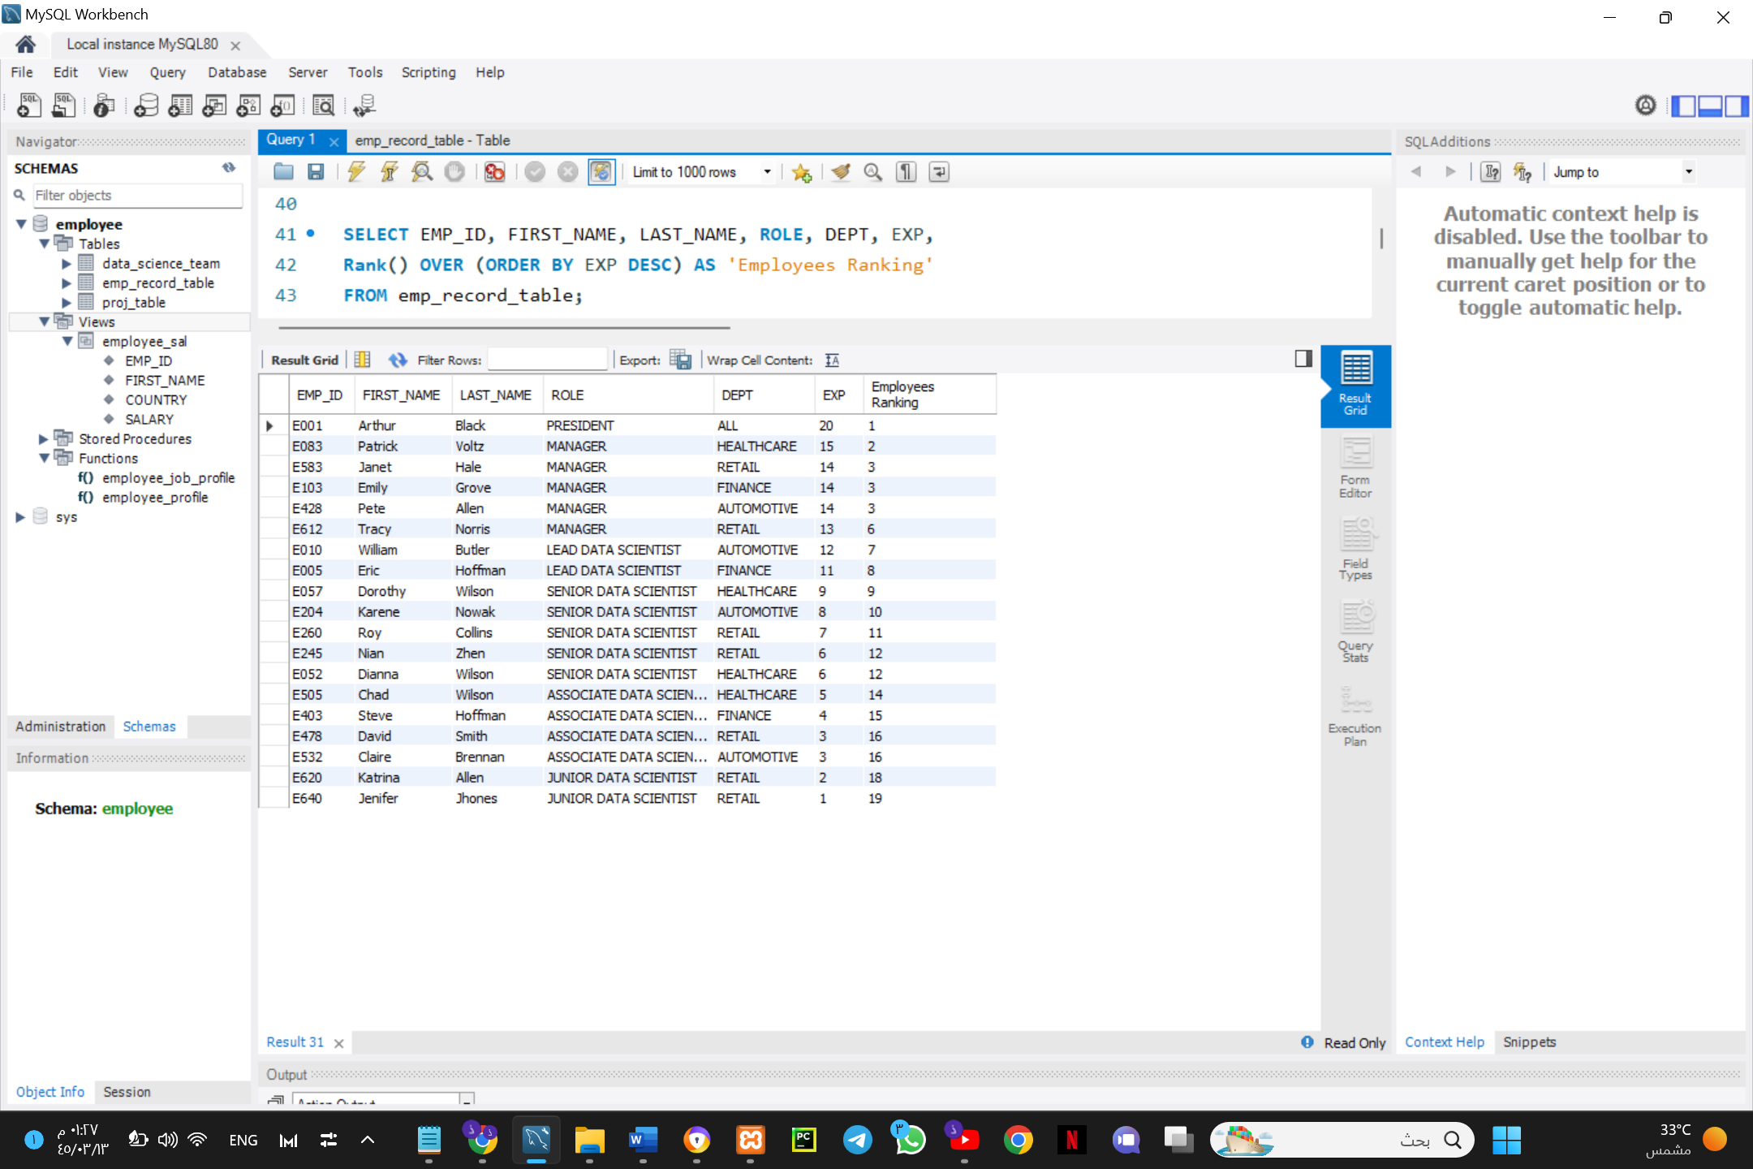

1. **Write a query to create a view that displays employees in various countries whose salary is more than six thousand. Take data from the employee record table.**

CREATE VIEW emp_view AS

SELECT EMP_ID, FIRST_NAME, LAST_NAME, COUNTRY, SALARY

FROM emp_record_table

WHERE SALARY>6000;

SELECT * FROM employee.emp_view;

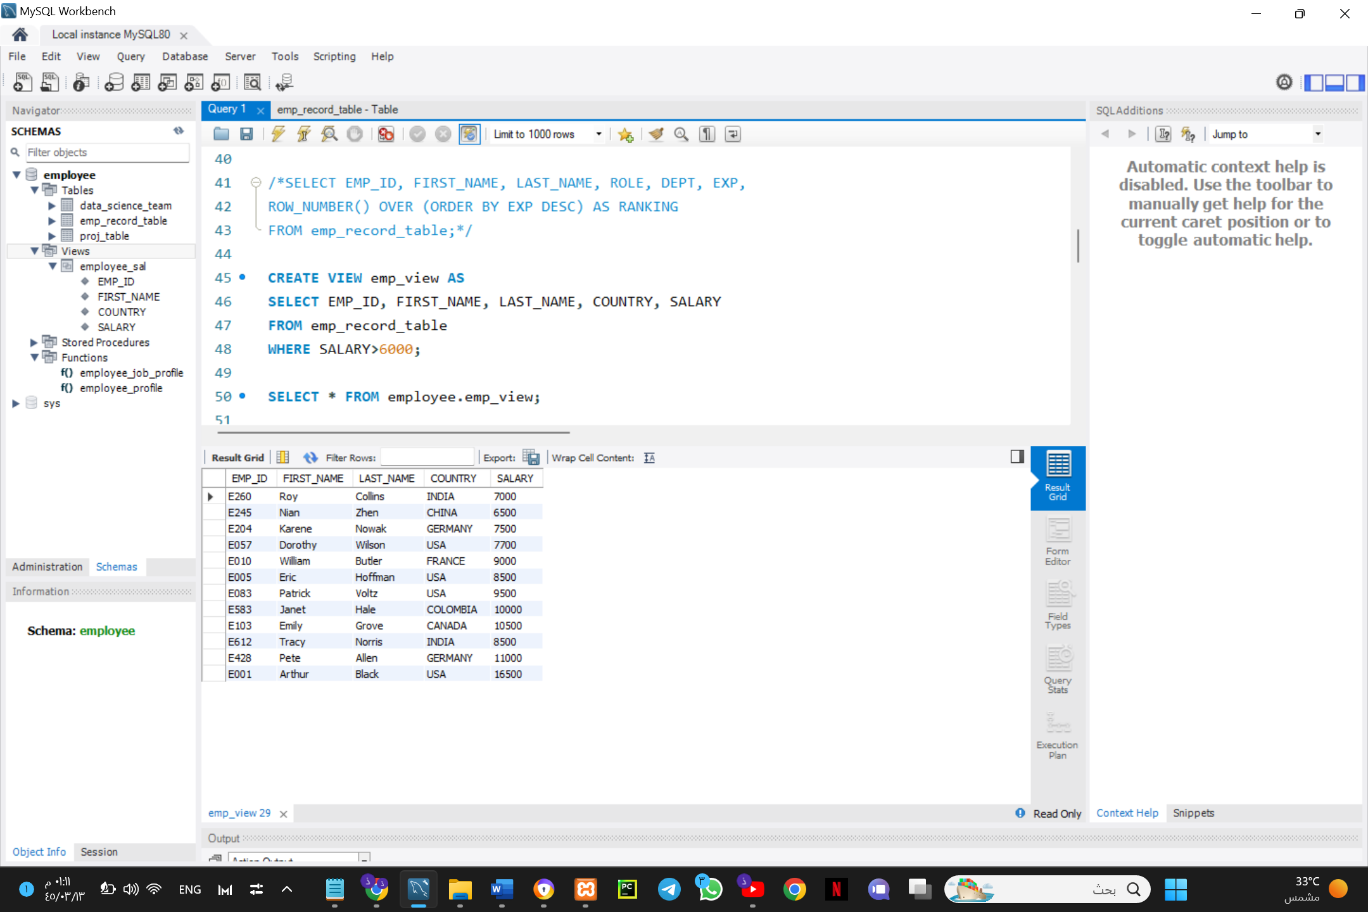

1. **Write a nested query to find employees with experience of more than ten years. Take data from the employee record table.**

SELECT EMP_ID, FIRST_NAME, LAST_NAME, EXP

FROM emp_record_table

WHERE EMP_ID IN

(SELECT EMP_ID

FROM emp_record_table

WHERE EXP>10);

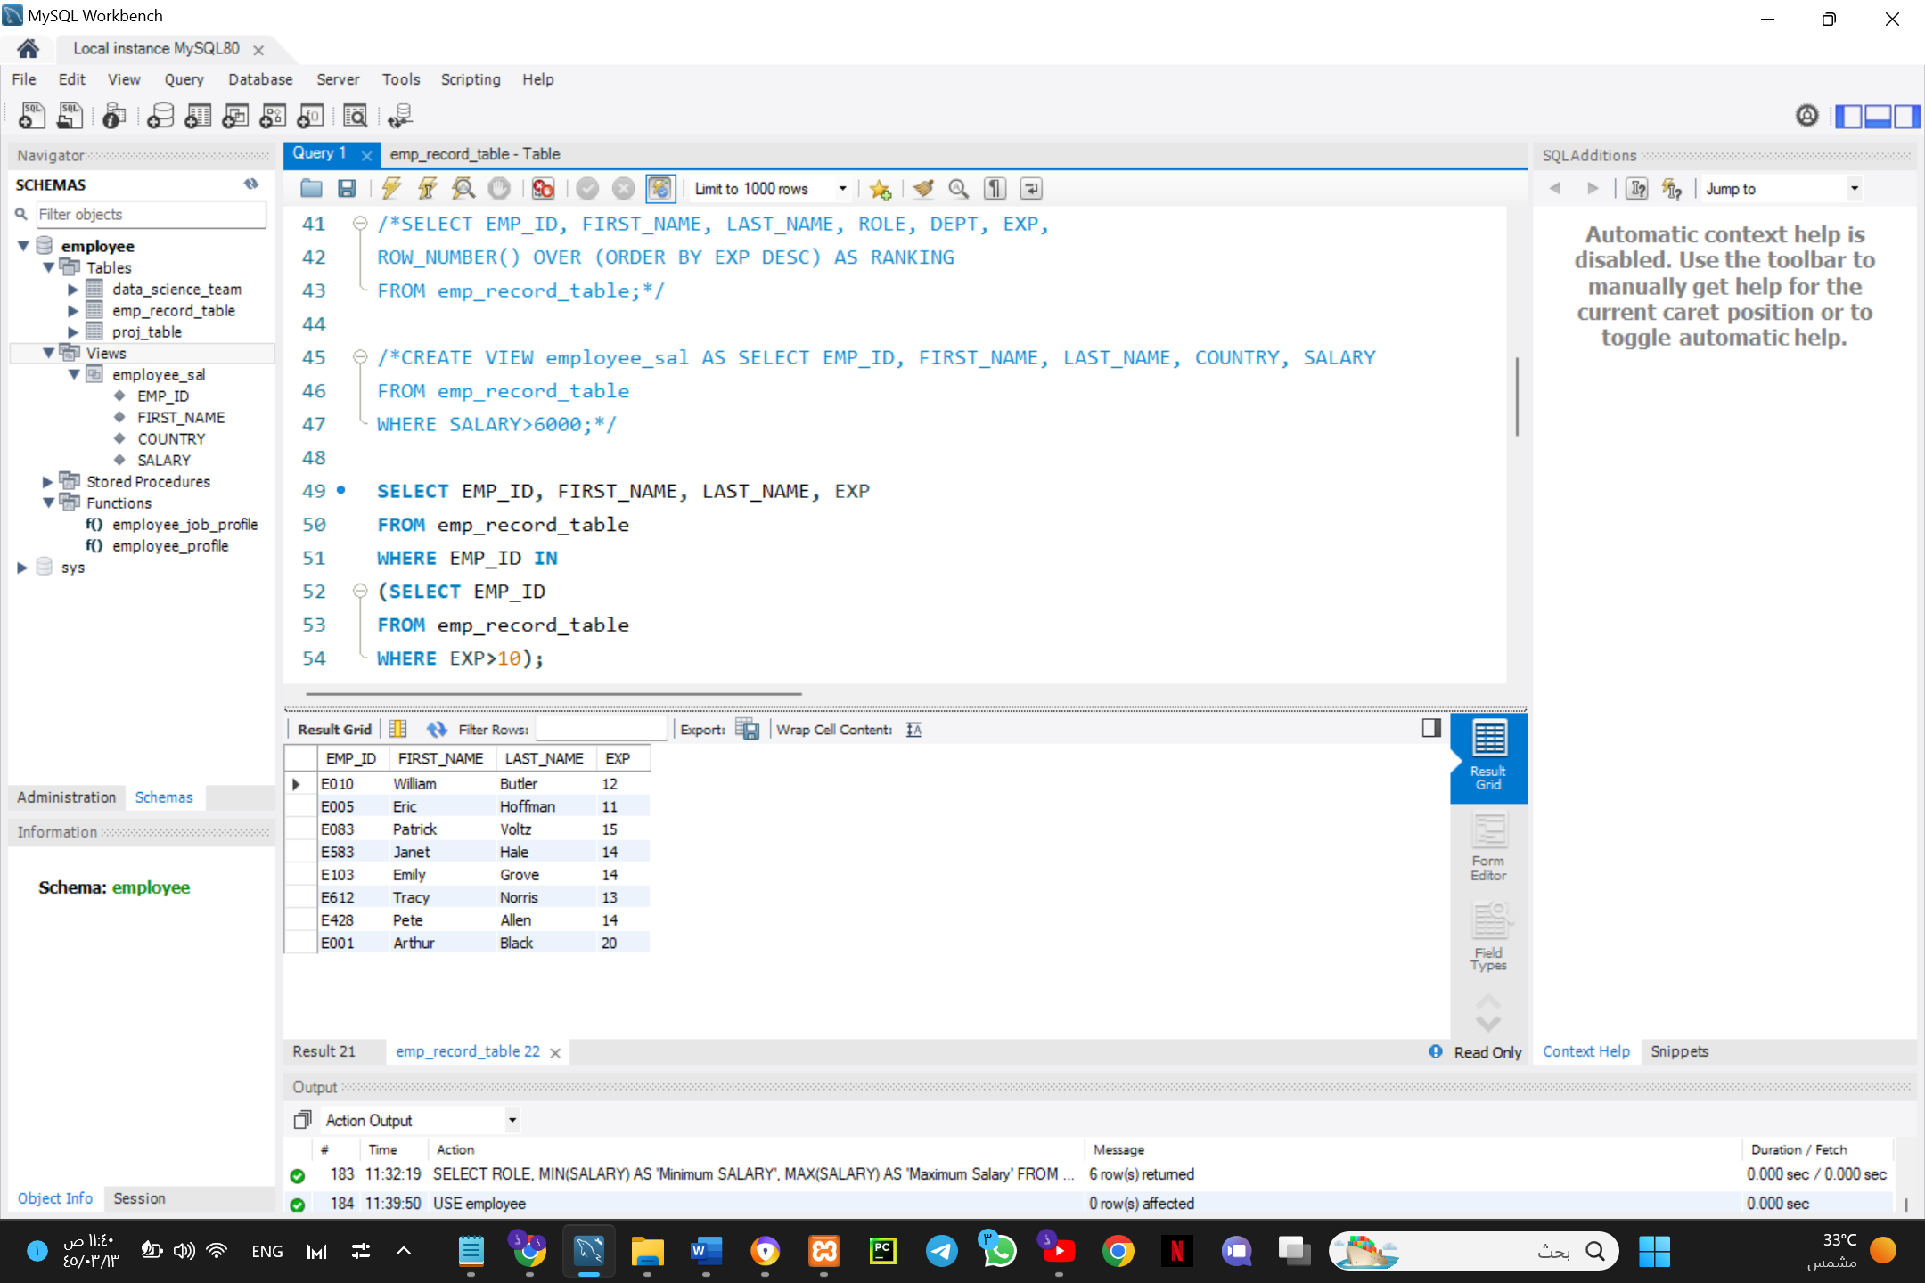

1. **Write a query to create a stored procedure to retrieve the details of the employees whose experience is more than three years. Take data from the employee record table.**

DELIMITER $$

CREATE PROCEDURE get_employee_exp()

BEGIN

SELECT * FROM emp_record_table WHERE EXP>3;

END$$

CALL get_employee_exp();

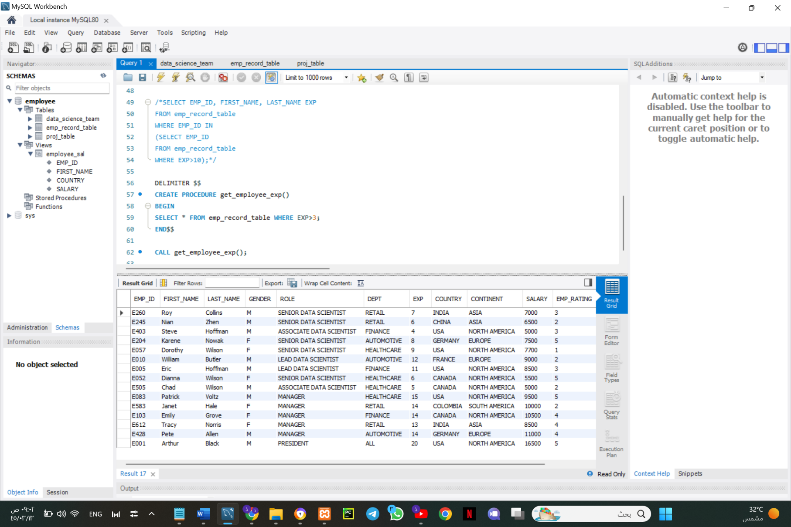

1. **Write a query using stored functions in the project table to check whether the job profile assigned to each employee in the data science team matches the organization’s set standard.**

For an employee with experience less than or equal to 2 years assign 'JUNIOR DATA SCIENTIST',

For an employee with the experience of 2 to 5 years assign 'ASSOCIATE DATA SCIENTIST',

For an employee with the experience of 5 to 10 years assign 'SENIOR DATA SCIENTIST',

For an employee with the experience of 10 to 12 years assign 'LEAD DATA SCIENTIST',

For an employee with the experience of 12 to 16 years assign 'MANAGER'.

DELIMITER $$

CREATE FUNCTION job_profile(EXP int) RETURNS VARCHAR(50)

DETERMINISTIC

BEGIN

DECLARE employee_job VARCHAR(50);

IF EXP BETWEEN 12 AND 16

THEN SET employee_job = 'MANGER';

ELSEIF EXP BETWEEN 10 AND 12

THEN SET employee_job = 'LEAD DATA SCIENTIST';

ELSEIF EXP BETWEEN 5 AND 10

THEN SET employee_job = 'SENIOR DATA SCIENTIST';

ELSEIF EXP BETWEEN 2 AND 5

THEN SET employee_job = 'ASSOCIATE DATA SCIENTIST';

ELSEIF EXP <= 2

THEN SET employee_job = 'JUNIOR DATA SCIENTIST';

END IF;

RETURN (employee_job);

END $$

SELECT EMP_ID, FIRST_NAME, EXP, job_profile(EXP)

FROM emp_record_table;

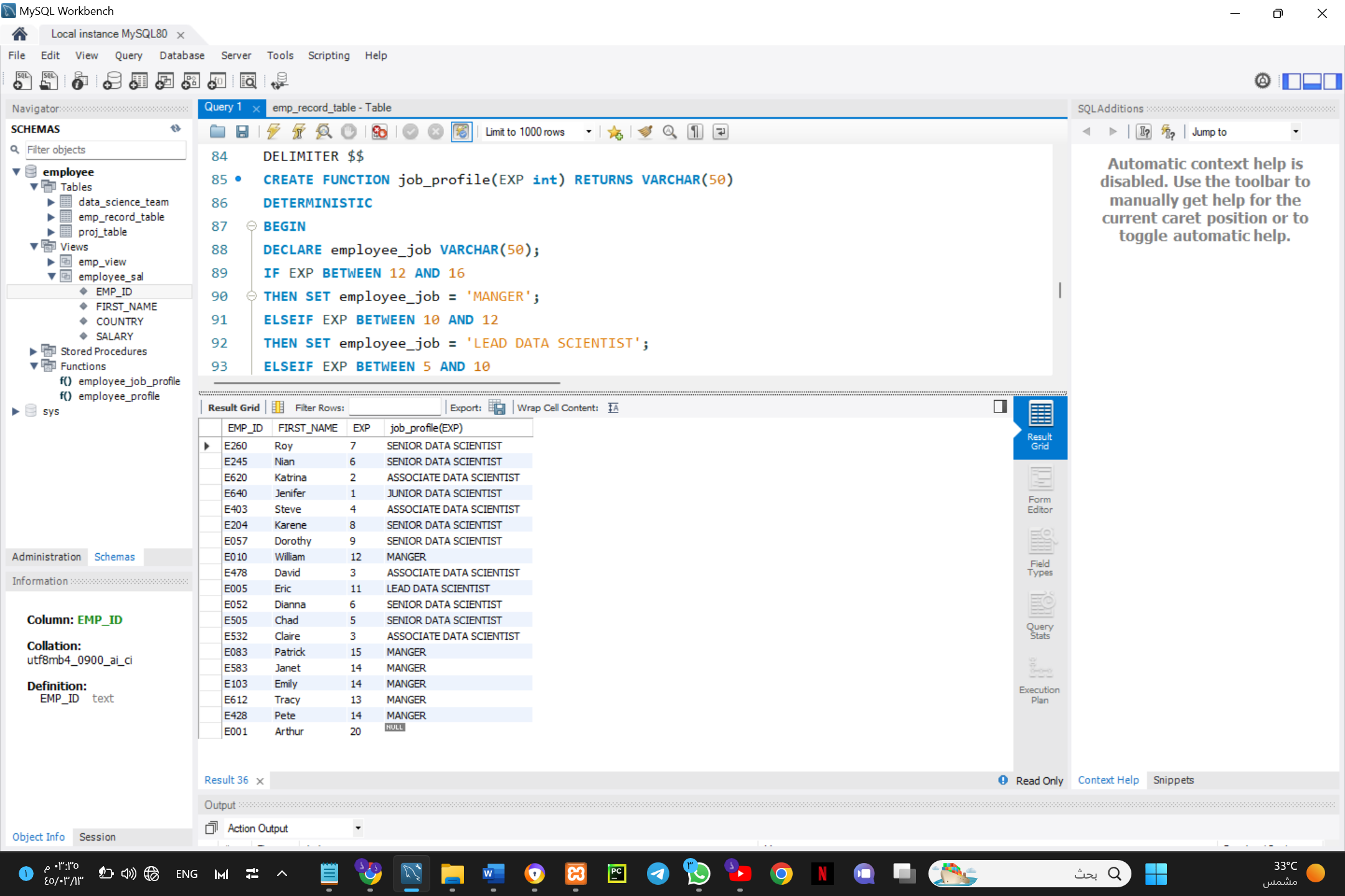

1. **Create an index to improve the cost and performance of the query to find the employee whose FIRST_NAME is ‘Eric’ in the employee table after checking the execution plan.**

CREATE INDEX idx_first_name

ON emp_record_table(FIRST_NAME);

SELECT EMP_ID, FIRST_NAME, LAST_NAME

FROM emp_record_table

WHERE FIRST_NAME= 'Eric';

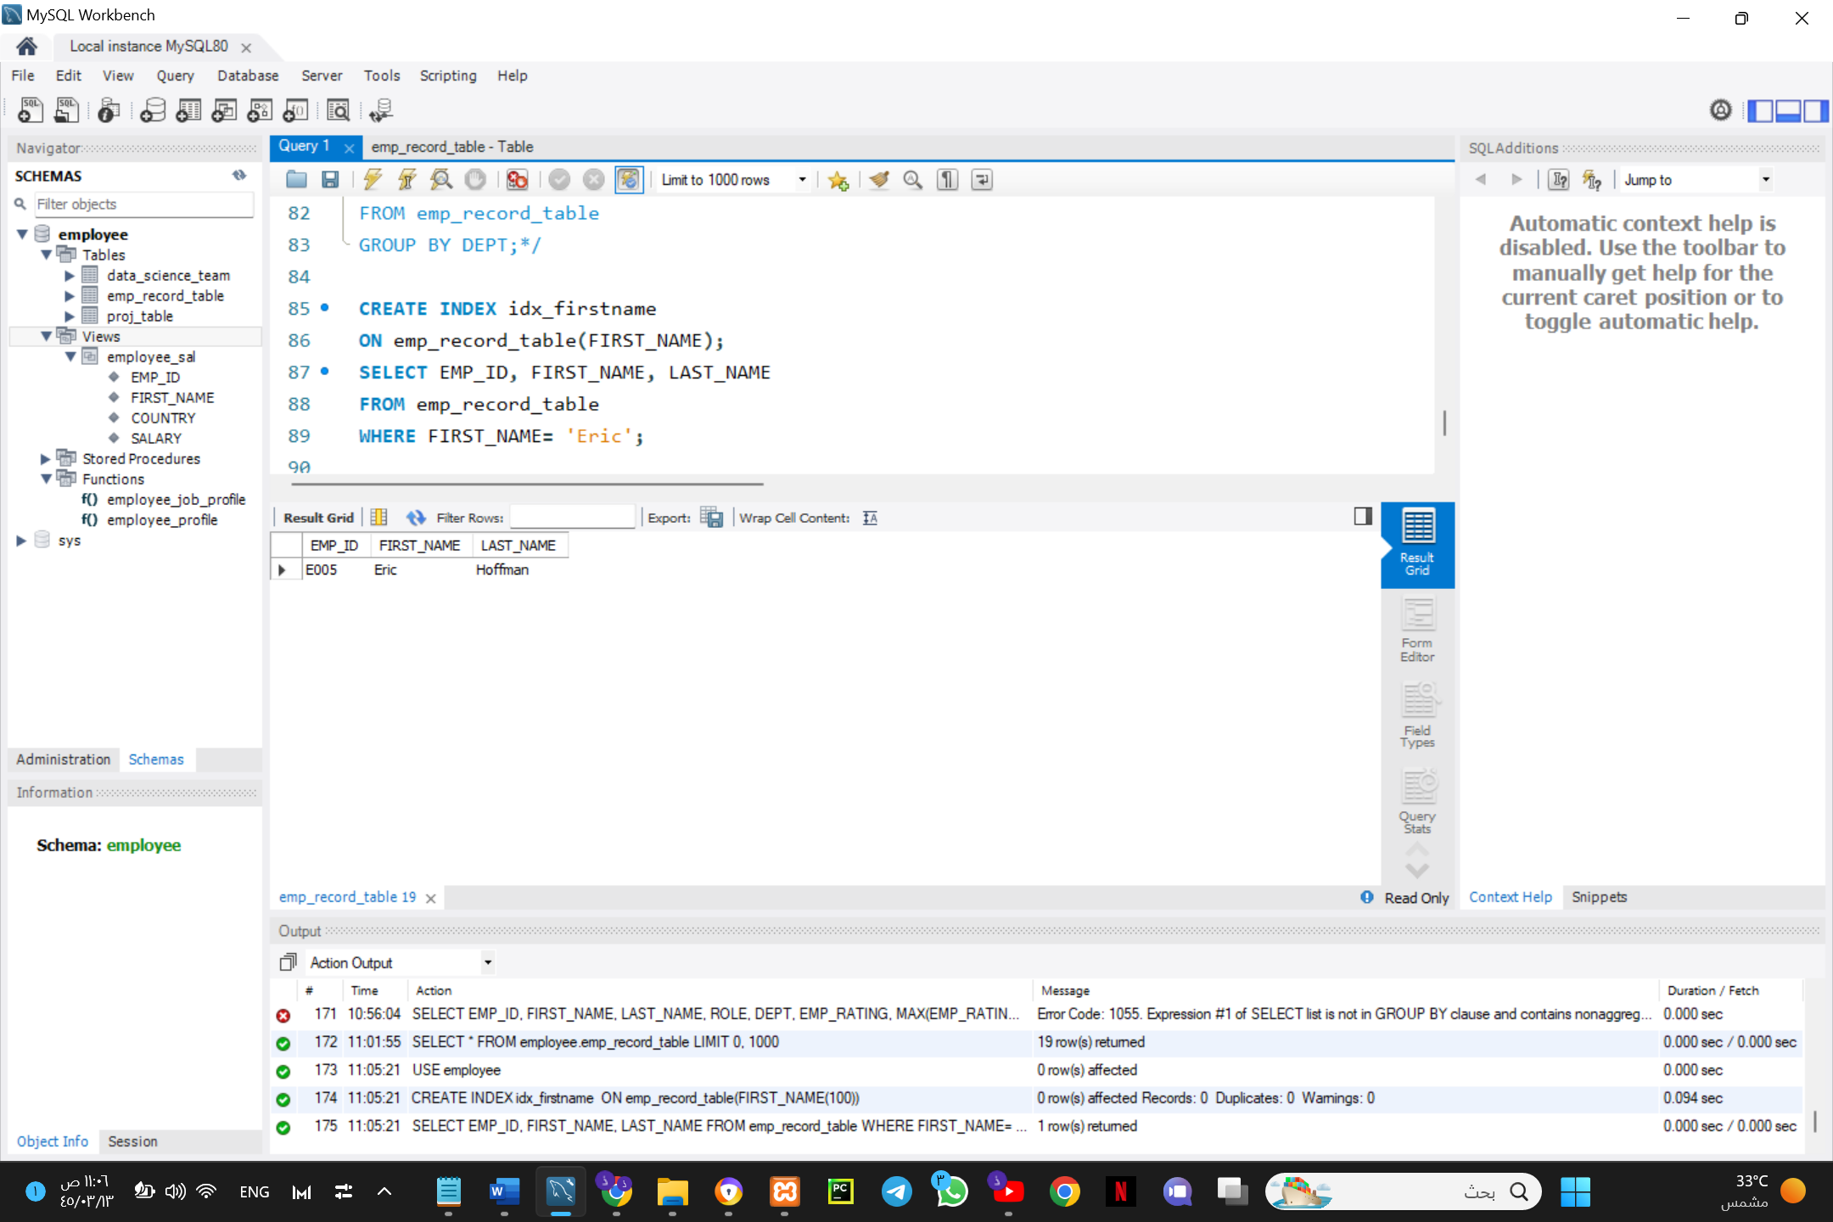

1. **Write a query to calculate the bonus for all the employees, based on their ratings and salaries (Use the formula: 5% of salary * employee rating).**

SELECT EMP_ID, FIRST_NAME, LAST_NAME, ROLE, EXP, SALARY,

EMP_RATING, (0.05 * SALARY)*EMP_RATING AS Bonus

FROM emp_record_table;

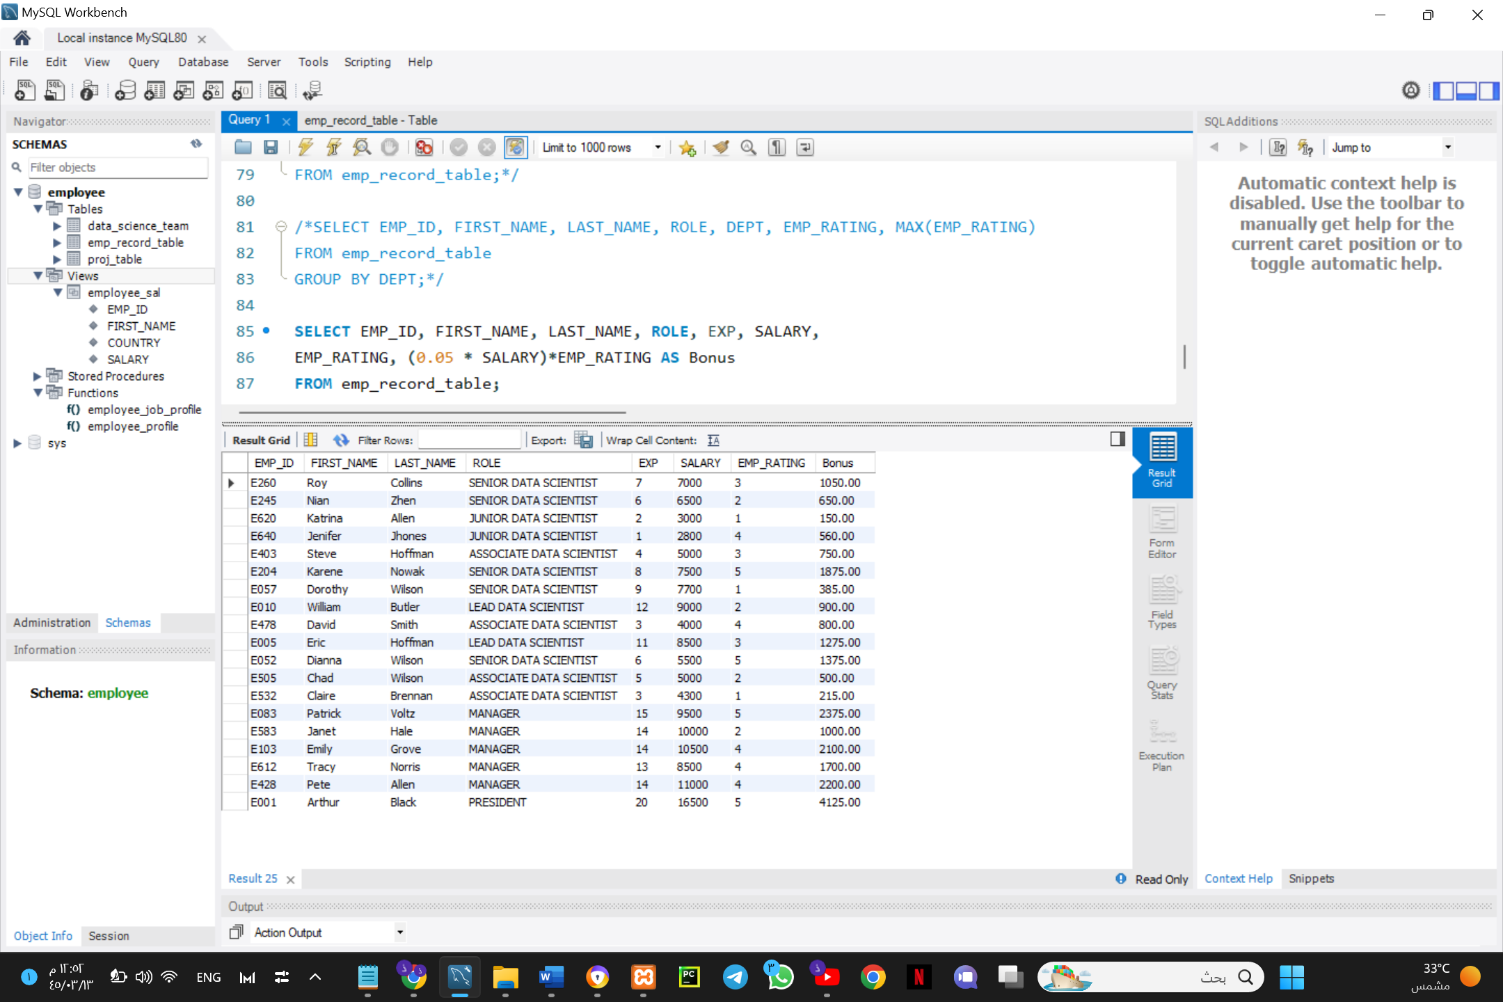

1. **Write a query to calculate the average salary distribution based on the continent and country. Take data from the employee record table.**

SELECT EMP_ID, FIRST_NAME, LAST_NAME, COUNTRY, CONTINENT, AVG(SALARY)

FROM emp_record_table

GROUP BY CONTINENT, COUNTRY;

